Final Project – Daniel Weng

I do not plan to work with a partner for my final project.

For my final project, I plan to make a fighting game/ defending based on the “Old One’s Army” event in terraria. The game consists of 3 levels and an endless level. The goal of each level is to protect a certain structure that enemies try to attack from both the left and the right side. If you successfully defeat all enemies and keep the structure standing, you win. If you die or the structure is destroyed, you lose. I plan to make 3-4 weapons the user can use and switch throughout. Each weapon will have a corresponding element (fire, ice, water, and electric is what I’m planning to use) and different abilities that go on a cooldown when used. I also plan on making an elemental reaction system with interactions between each element. For example, if fire and ice come into contact, a “melt” reaction would occur and would deal bonus damage to enemies if and water and electric come into contact, it will cause an “electro-charged” reaction that stuns the enemies and deals damage over time. Additionally, you gain gold from defeating enemies and can use the gold to upgrade your character’s stats or upgrade your weapons’ stats.

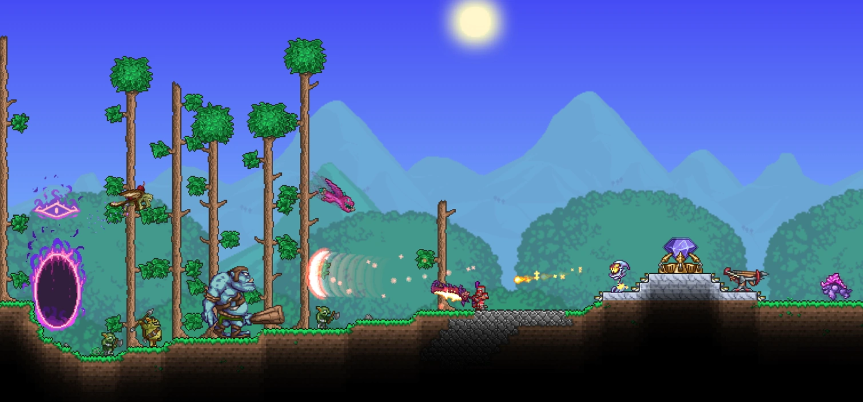

Bloons td

Streetfighter game (Super smash bros??) (switch characters) (elemental reactions??)

Geometry dash

Soul knight

Terraria

Platformer